In order to onboard the voice team data the first step was to get the logs and events created on which the onboarding is to be done to do so we created the python script which randomly generates the data and saves it in csv format in a new file.

1. Now we have the data and we are good to onboard this data in to splunk,hence we created Apps named as –
2. **Avo_TE_Voice_Collector** – This App will be collecting the logs from the csv file, for this we have added a monitoring stanza in the inputs.conf

The Index named as “te” and sourcetype as “voice”

1. **Avo_TE_Voice_Parser** – This App will be Parsing the onboarded data using props.conf
2. **Avo_TE_Voice_Team_App** – This App contains the UI to be shown and the data model files.

NOTE : All the Apps Mentioned above are present in the Deployment Server.

1. **Avo_TE_Voice_Collector** - The Monitoring Stanzas used in **inputs.conf** are as below :

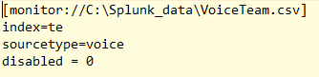

**Avo_TE_Voice_Parser** - The **Props.conf** used :

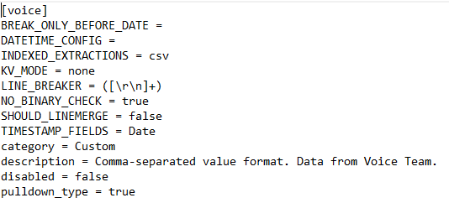

**Avo_TE_Voice_Team_App –** The data model and the dashboard files are present in the defaults folder.

1. The events in Splunk looks like below :



1. The Dashboards Created for voice named as “Voice Team”.

Link to Dashboard : <https://192.168.0.143:8000/en-US/app/Avo_TE_Voice_Team_App/Voice_Team>

Dashboard Screen Shot :

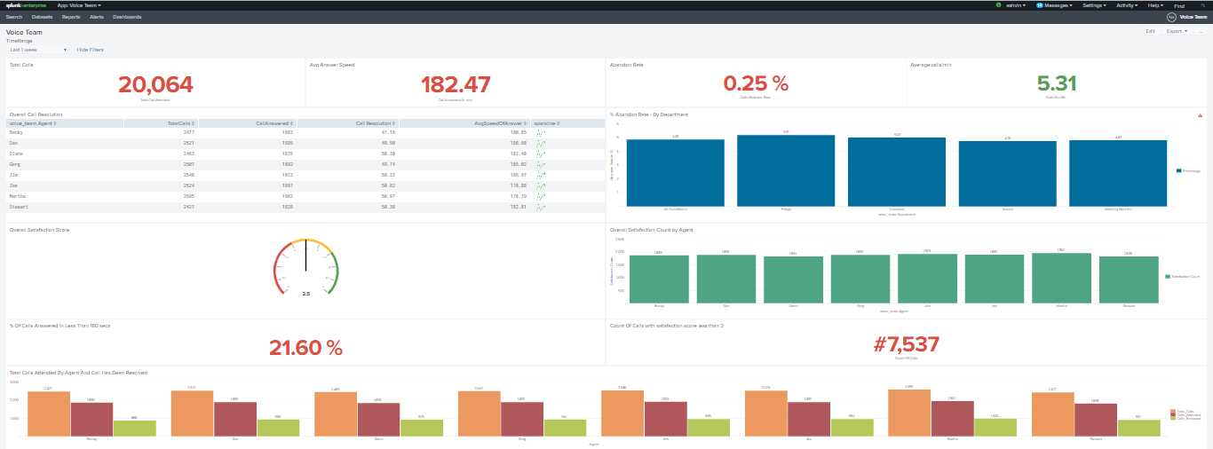

Dashboard in HTML (removed header, Edit option and search, inspect job options)

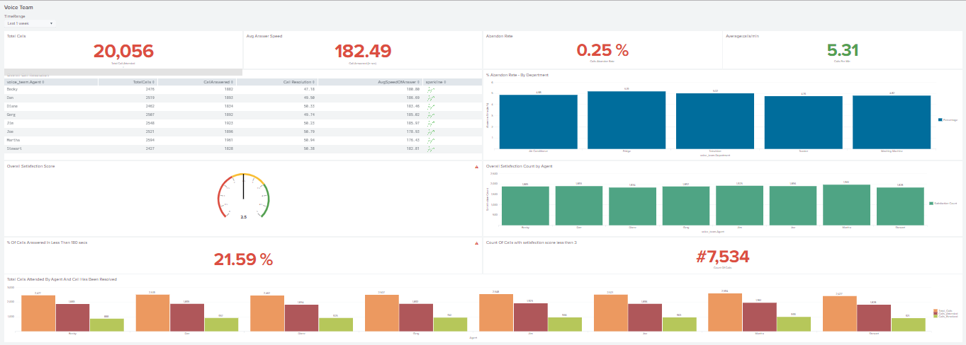

The Dashboard runs on the Data Model with a summary range of one month, here is the link to datamodel – [click here](https://192.168.0.143:8000/en-US/app/Avo_TE_Voice_Team_App/data_model_editor?model=%2FservicesNS%2Fnobody%2FAvo_TE_Voice_Team_App%2Fdatamodel%2Fmodel%2FVoice_Team)

1. There is also an Alert named “**Feed Missing : Voice Team**” with Triggering Condition: Number of Results is = 0, if the condition is satisfied which means no voice data coming in to splunk and a mail will be sent to Ashvin and Vignesh respectively.

The link to Alert : [click here](https://192.168.0.143:8000/en-US/app/Avo_TE_Voice_Team_App/alert?s=%2FservicesNS%2Fnobody%2FAvo_TE_Voice_Team_App%2Fsaved%2Fsearches%2FFeed%2520Missing%2520%253A%2520Voice%2520Team)

NOTE : The Search Head I used here for demonstration is [https://192.168.0.143:8000](https://192.168.0.143:8000/)